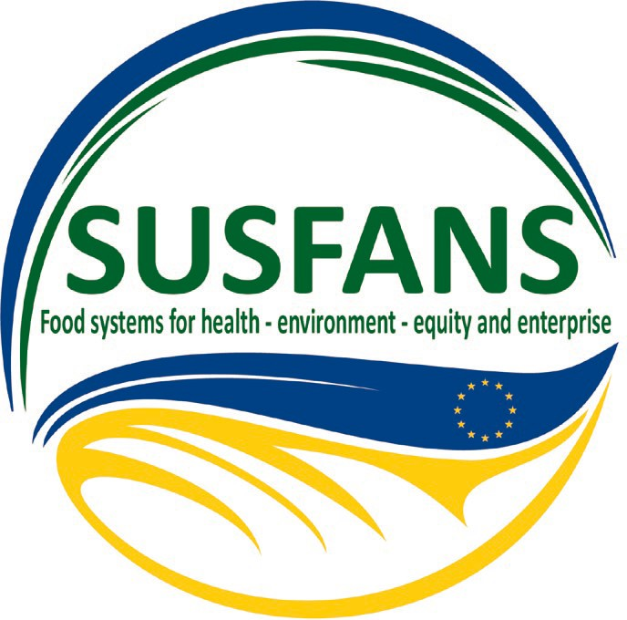
PRESS RELEASE, 12 June 2019

Achieving sustainable food system in the European Union
EU –funded project SUSFANS provides an integrated perspective on the EU’s food system for science and policy.

The SUSFANS project team shares the scientific results of four years of intensive research. SUSFANS has been working with a group of international researchers from around 10 European countries and a group of 30 stakeholders from industry, academia, policy and non-profit organizations. Four stakeholder meetings were held in the Czech Republic, Denmark, France and Italy and case studies in these countries were conducted.

“Our objectives were quite ambitious”, tells Thom Achterbosch, SUSFANS project leader based at Wageningen University Economic Research in The Hague, The Netherlands. “We wanted to involve partners from all levels of the food system and from different sectors (research, industry, consumers, policy) and European countries in order achieve EU food systems that contribute to health, environment, equity and viable enterprise. We have done this by delivering high-quality research on metrics, models and foresight so we can support evidence-based policies and innovation strategies for a sustainable and food and nutrition secure EU”.

Main messages and outcomes of SUSFANS:

The EU food system is not "future-proof" enough in terms of sustainability performance. Current nutritional patterns are in imbalance, their environmental impact too large, economic viability and social justice are under pressure.

Despite substantial regional and cultural variation in diets, challenges for EU consumption patterns are similar:
1. There is a need to shift to a reduction of energy intake. 2. There should be more intake of fruits and

vegetable, legumes and nuts. 3. There should be less intake of Greenhous Gas emission-intensive consumption (meat, especially red meat) and 4) less added sugar, 5) intake of key micronutrient in replacement should be promoted.

SUSFANS has developed a novel approach to quantify diet change, as well as policy and production system innovations:

1. Include EU-specific intake data in the framework, benchmarking national data against a reference sustainable, healthy diet for EU. 2. Model the entire system, including post-harvest food handling and retail. 3. Explore instruments and transformative pathways including economic sustainability and equity.

The 2030 Agenda on the Sustainable Development Goals offers opportunities for bending EU food system from quantity-driven to quality-driven:
1. Growth, demography, and trade drivers suggest window of opportunity for aligning EU agriculture with environmental boundaries while remaining globally competitive as sustainable producer. 2. Various drivers of sustainable consumption among EU consumers are in line with health benefits, higher value added. 3. Involve consumer drivers in employing new metrics (e.g. emission per diet quality index instead of per ton) in decision-making on innovation strategy for industry. 4. Economic sustainability requires re-think of the position of farmers and producers.

Key conclusion: it is possible for the EU to move towards sustainable diets and a sustainable food supply system in a matter of decades, but only with a proper transformation of production, consumption and trade.

Learn more about the SUSFANS project at https://www.susfans.eu

Contact: Alma van der Veen, presse@zef.de or Khadija Naïri, Wageningen Economic Research (WUR), susfans@wur.nl

